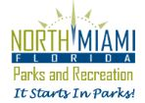
PILATES AND YOGA
With Instructor Claudia Zoeller
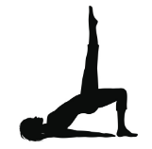
At the Keystone Community Center, 13050 Ixora Court PILATES ages 16+
WEDNESDAYS 7:30 – 8:30 pm
Resident: $5 Non-resident: $8
This unique workout builds core strength, coordination, balance and flexibility through a series of mat exercises, toning your entire body.
YOGA
SATURDAYS 11:00 – 12:00 pm
Resident: $5 Non-resident $8
This vinyasa-style yoga class is designed to help anyone looking to learn the foundation of yoga postures, alignments and breathing techniques. Classes build endurance, flexibility and strength in a supportive environment that encourages he link between mindfulness, breath, and movement. Classes are recommended for beginners as well as those with an ongoing practice.
Proof of residency is required. You may register at the community center at each class or purchase a series of classes.
More information at North Miami Parks: 305-895-9840

